CURRICULUM VITAE

WAQAS KHAN

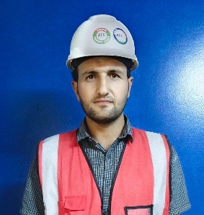
- Phone: 0556302808
- Email: Waqaskhan1184@outlook..com
- Address: Riyadh - Kingdom of Saudi Arabia
- Visa Status: Transferable as per Saudi Labor law
- Five years’ Experience

PERSONAL SUMMARY:

To work in a challenging environment where I can utilize my accrued knowledge and enrich my professional skills, while contributing significantly to the company's growth and profitability.
Working as HSE Safety Professional to save humanity and become a part of Saudi new vision of construction and become part of international professional Team.

EDUCATION:
MCS (Master of computer Science Abdul Wali Khan University Mardan)
Diploma Associate Engineering Mechanical (3 Years)
Diploma in Environmental Engineering (3 Years)

CERTIFICATES:
- NEBOSH IGC –International General Certificate UK Level-3.
- 30-Hour Construction Safety OSHA compliance Course.
- Institution of occupational health and safety (IOSH)
- One-day Training for First Aid and CPR from Syed International Training and Consulting (SITC) Pakistan.
- First AID
- Fire Safety
- Optical Fiber- One Year Diploma
- Data entry/ Archive Management

HSE AWARDS:
  - 01 million Safe Man-hours without LTI at STC Square Project, Riyadh
  - 02 million Safe Man-hours without LTI at STC Square Project, Riyadh
  - HSE Performance certificate for Safe Compliance

STRENGHT:

- Strong interpersonal skills
- Self-confidence, motivation and good communication skills.
- Ability to learn quickly and accept new responsibilities.

WORK EXPERIENCE

Currently working

- COMPANY BEIJING EMIRATES CONSTRUCTION COMPANY
- Position HSE OFFICER
- From O1 October 2022 to Still Working.
- Project Name STC Square
- Client Aqalat Company LLC.
- Consultant Saud Consult.
- Location Riyadh, kingdom of Saudi Arabia



- COMPANY Zamil Steel
- Position HSE OFFICER
- Project Sound storm 22 Bin Ban Riyadh
- Duration July 2022 to Sep 2022

- COMPANY BEIJING EMIRATES CONSTRUCTION COMPANY
- Position HSE OFFICER
- From August 2018 to 30 December 2021
- Project Name KAP2E2-E4 & E5 - Madinah.
- Client Ministry of interior kingdom of Saudi
- Arabia Consultant Sawaed, Architects Planners, Engineers
- Location Madinah, kingdom of Saudi Arabia.

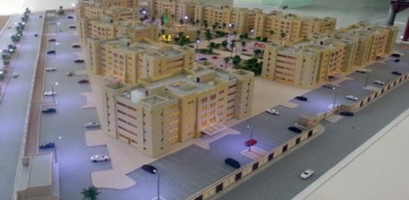

DUTIES & RESPONSIBILITIES:

  - I attend daily and weekly (TBT) tool box talk.
  - Support implementation of arrangements for H&S.
  - Making others aware of legal obligations.
  - Support management in promoting H&S.
  - Conducted fire drill training.
  - I prepared daily, weekly and monthly safety report
  - Conducted workplace Inspections of power tools and hand tools to make sure the equipment is fit for the task.
  - Involve in senior management team reviews of H&S performance.
  - Report site accidents / incidents to the Senior Management and Regulatory Authorities.
  - Reporting to Senior Management on HSE issues / performance.
  - Preparation and implementation Emergency Response Plan.
  - Conducting site inspections, report preparation, reporting to Senior Management
  - Develop action plan for close-up inspection findings
  - Safety induction for new Employees.
  - Hazards identification and their elimination.
  - Checking of all work Permits daily at jobsite.
- To maintain safe working condition in work site.
- To maintain the first-aid facilities in the work site.
- Understanding and evaluation of project according to requirement of the work.
- My main goal is zero accident.

COMPUTER SKILLS:
- Almost all application to run a computer.
- Optimization
- MS Word
- Mailing
- Intranet

LANGUAGES:

- English
- Urdu
- Pashto
- Arabic

REFERENCES:

Ghufran Qadri, HSE Project Manager, BEC Arabia : ghufran.qadri@becarabia.com / +966 59 323 5764

