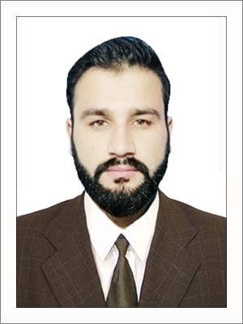
Noorulhaq (Safety Officer)
(NEBOSH -IGC Certified, BA Arts)
Mob & What’s App: 0552696850
Passport number; CF6398851
Email: noorulhaq0336@gmail.com
_______________________My Goal to Achieve Zero Accident
CAREER OBJECTIVE
To work with a team in a well reputed Company, which has the potential to unearth individual excellence, can provide an opportunity to apply my technical, Innovative, and leadership skills to produce satisfying, exclusive and successful solutions to problems by using my professional skills in Safety and Health in challenging work place by generating new ideas and create positive change. It will be utmost important for me to exert my sincere efforts for the excellence & betterment of Company to compete in market strongly.

Project : Capriole Construction L.L.C
Company: Cost of-14 Residential Buildings for Etihad (Abu Dhabi)
Position: HSE Officer
Duration: 15 Aug 2019 to 30 oct 2020.

Detail Responsibilities as a HSE Officer:

- Generate monthly HSE reports.

- Carryout periodic OH&S risk assessments and Environmental impact

- HSE training program and monitor employees ‘Training.

- Daily HSE supervision in the facility and premises.

- To lead HSE tool box meetings.

- To manage the HSE filing system and records controls.

- To carryout special HSE improvement Projects.

- Timely reporting and investigation of HSE incidents as per the requirements.
- Induction and Importance of General Safety and Environment on site for the new comers, workers and visitors visiting the site

- Implementing company safety policy at site

- Supervision of sub‐contractors

- Carrying out risk assessment and job safety analysis
- Update and monitor corrective action log inspections, audits, drill findings and incidents.

- Update and monitor waste manifestation system.

- Assist in the review of subcontractor documentation as required.

- Co‐ordinate Meeting minutes for daily subcontractor meeting, weekly safety meeting and monthly HSE meeting.

PROFESSIONAL QUALIFICATION & CERTIFICATION IN HSE FIELD.
•NEBOSH IGC (UK) Roll Number 00549763.
The course covers:
IGC1 - Management of international health and safety
IGC2 - Control of international workplace hazards and risk
IGC3 - International health and safety practical application

- IOSH Managing Safely (U.K)

- OSH Academy (USA. 48 Hr)
- HSE Diploma 2years (Pak)

- Risk Assessment Management, (EIOSH Pak)

- Permit to work
- First aid (U.K)
- First aid (U.A.E)
- First aid (PAK)
- Fire safety (U.K)
- Work at height (EIOSH pak)

HSE short courses:
Site Supervision | Permit to Work System | Crane Operation Major
 |  | principle
Accident Investigations | Job Hazard Analysis
Accident Investigations | Job Hazard Analysis | procedure
Lock Out Tag Out (LOTO) | Safety Inspection Skills | Accident Incident reporting
Risk Management System | Accident Reporting | Team Motivation

ACADEMIC QUALIFICATION
BA (Bachelor of Arts)
F.Sc Pre-Engineering
Matriculation science

Computer skill
MS OFFICE, MS Power point etc

PROFESSIONAL SKILLS
- Communication skills

- Reporting skills

- Facilitation skills

- Training skill

LANGUAGES KNOWN

English, Urdu, Pashto.

