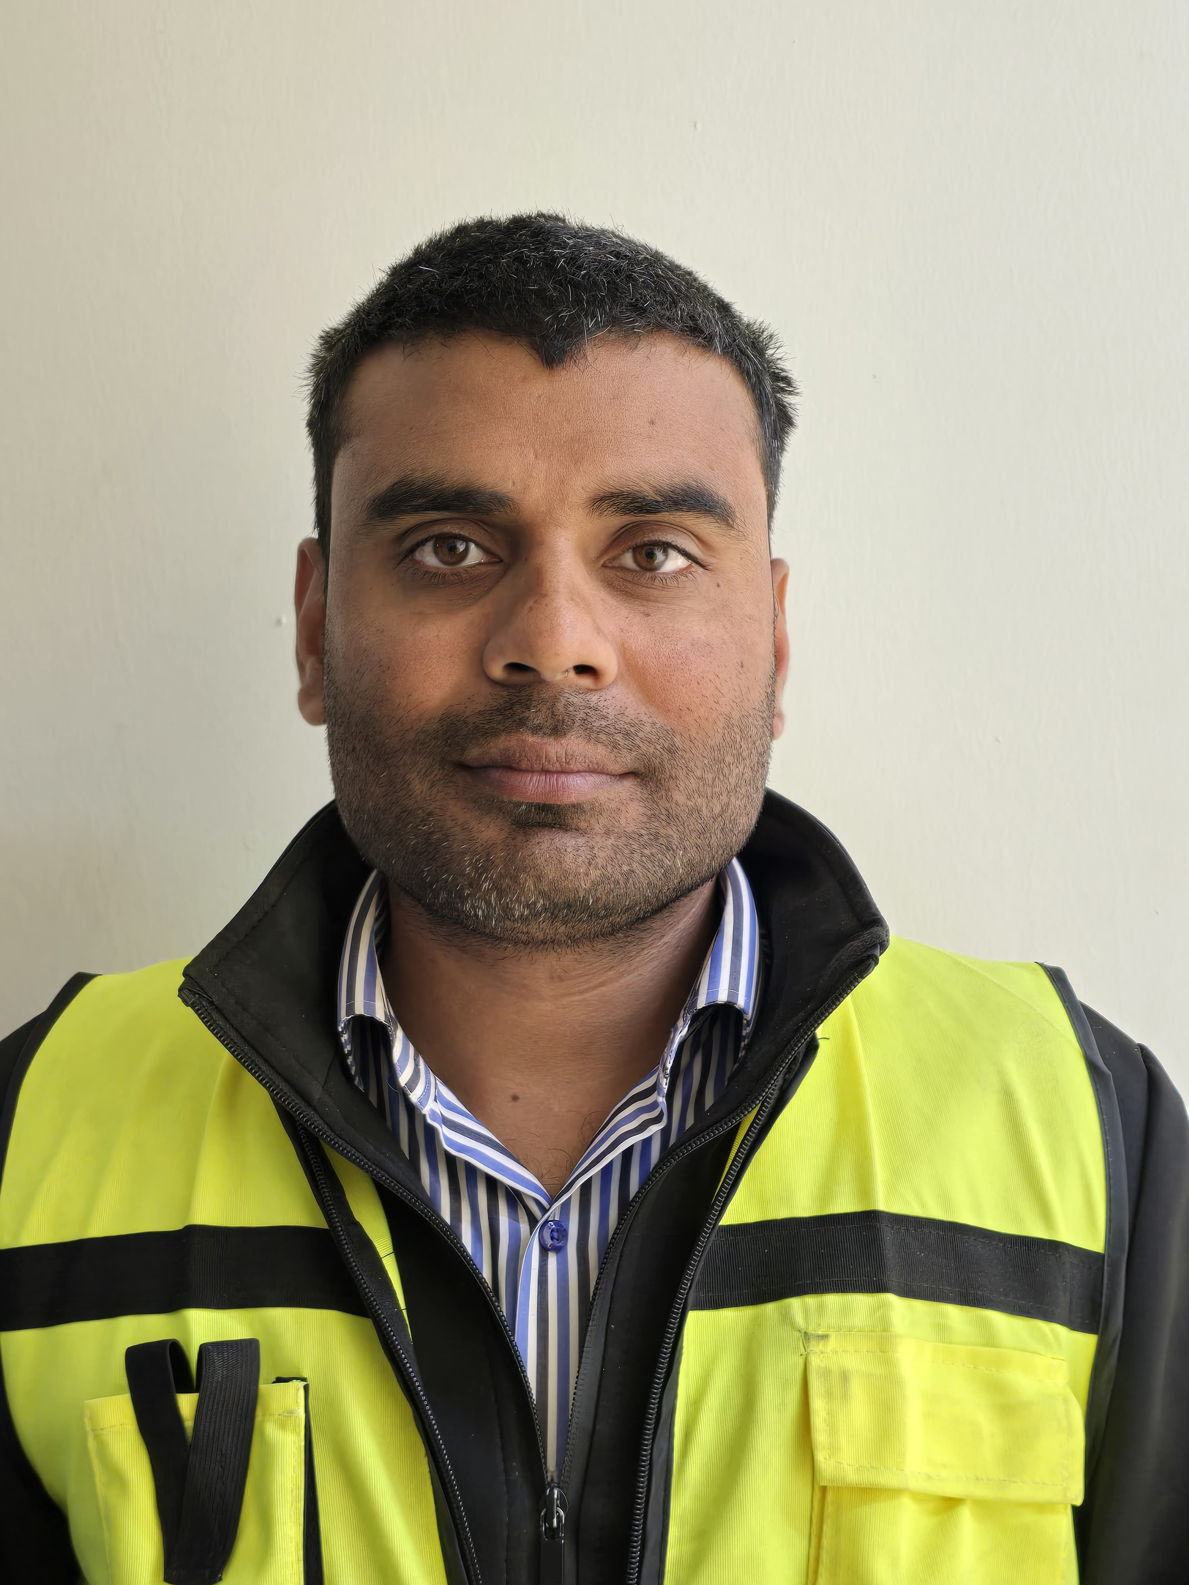
Aqeel Sultan
HSE OFFICER
Address: Jubail, KSA

Contact: +966 553189171
Email: Aqeelsultan91@gmail.com
Nationality: Pakistani
(Immediately Available)
Approved By : USACE ( US ARMY CORPS OF ENGINEERING)

OBJECTIVE
As an Environmental Health & Safety Professional, my primary objective is to impart the fullest of my abilities in ensuring that all the people involved in the company comply with the environmental protocols. My experience has broadened my understanding and enhanced my skills. My aim is to ensure that every employee is well-equipped to respond to emergencies by designing and conducting regular trainings. I also aspire to constantly improve my administrative abilities and to cultivate the safest working environment possible for all.

EDUCATION

- Higher Secondary School Certificate
BISE, Gujranwala

• Secondary School Certificate
BISE, Gujranwala

EXPERIENCE

Professional Experience
I am an Environmental Health & Safety Professional with Seven ( 7 + ) years of extensive experience in all aspects of Environmental Health & Safety related activities in construction industry.
I also have an extensive knowledge of Construction Industry, my areas of specialization include, but are not limited to, the following:
- Environmental Induction Programs
- Chemical Storage Precautions
- Waste Management Storage and Segregation
- Dust Control Precautions
- Noise Control Precautions
- Waste Water Management
- Chemical Spillage Soil Contamination Control Trainings.
- Occupational Health and Safety Environment Reporting.
- Incidents Investigation.
- EHS Trainings
HSE officer :Alayuni Investment & Contracting Company
2021 TO Present
Roles and Responsibilities:
- Daily, weekly & monthly site walks through & inspection.
- Induction to the newly employees regarding Environmental issues.
- Making & Maintaining site observations on daily, weekly & monthly basis record.
- Ensures dust control precautions on access road, stock piles & crusher area.
- Ensures environmental precautions regarding waste management and segregation.
- Look over oil spillage and refueling activities.
- Ensures dust control measures at backfilling areas.
- Responsibility to protect Flora & Fauna.
- Maintaining the documentation regarding PTW, Induction, WIR and TBT.
- Submits weekly environmental observations and reports to the client regularly and maintaining record.
- Maintaining chemical storage area and its COSHH assessment.
- Maintaining internal and external reports regarding environmental issues.

NAN TONG CHIANJIN Riyadh, KSA
12/2019 - 08/2021,
Roles and Responsibilities:
- Facilitating Environmental trainings for employees in safe work practices for newly hired, such as but not limited to: Housekeeping, Maintenance of Powered Industrial Tools, Oil Spillage, Haz Waste.
- Performing Environmental Inspections and Internal Audits, prepares written reports of findings and recommendations for corrective or preventative measures.
- Promoting generative EHS culture.
- Assist in the Review and Recommend Actions on Contractor’s submittals such as EHS plans including Waste Management.
- Environmental Monitoring, Incident Reporting, Emergency Response, and Permit to Work (PTW) for the construction activities to comply with Internal and External EHS Regulations.
- Carrying out Environmental monitoring report and review.

AL SAHEL CONTRACTING COMPANY (ASCC) LLC Jeddah, KSA
08/2016 - 11/2019,
Roles and Responsibilities:
- Prepared Monthly Training Schedules and Conducted Trainings related to the EHS Policies of the Company and contractor employees.
- Prepared Environment Analysis Reports of routine and non-routine activities of the Company on on-going basis.
- Facilitated user department for development and implementations of procedures / SOPs as per OHSE management system.
- Designed and conducted trainings for learning and development of the EHS Coordinators in areas such as environment and safety laws & regulations, EHS procedures and use of Health Safety and Environment Monitoring.
- Generating and Promoting environment friendly culture on project site.

Philip Morris International,
08/2015 - 07/2016,
Roles and Responsibilities:
- Developing effective environmental culture by implementing approved policies and procedures.
- Coordinate with third parties for monitoring of gas pollutants, emissions, vehicles, drinking water, air quality and noise control.
- Assist in regular leadership walk through and meetings with directors, managers, team leaders and project representatives.
- Assure reporting, investigation, mitigation and appropriate communication of project environmental incidents are undertaken in a timely and appropriate manner.
- Dust management during site preparation and earth works.
- Carrying out environmental audits and accident/incident investigations to identify the areas for system enhancement and continual improvement.

CERTIFICATIONS

- International General Certificate (IGC) in Occupation Health & Safety from National Examination Board for Occupational Health & Safety (NEBOSH) UK
- IOSH Manage Safely V5.0
- 30 Hours Construction (OSHA)
- First Aid at Work (AOSH)
- Confined Space Safety
- Accident Investigation
- Scaffolding Safety
- Work at Height
- Permit to Work System
- Electrical Safety
- Crane Lifting Safety

KEY SKILLS

- Ability to maintain confidentiality of all data.
- Microsoft Office
- Power app
- E-mail
- Can make and present presentations
- EHS Trainings
- EHS Reporting
- Accident/Incident Investigation
- Substantial experience in monitoring various activities in high risk industries.
- Participating in emergency response plan development.

CAREER SUMMARY

As a motivated and Environmental Health & Safety Professional I thrive in challenging environment. Professionally, I would like to contribute effectively towards the goals of the organization and its stakeholders. I believe learning is a continuous process and I like to constantly enhance my knowledge and skills for a successful and fulfilling career. My motto in life is to give your hundred (100) percent in every second of your work. Result will surely be a success.

• Available upon request

