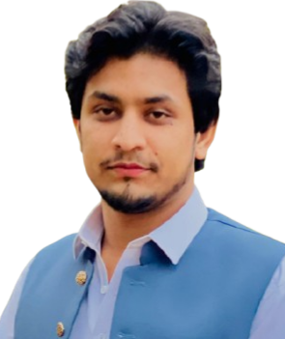ABDULLAH NISAR

I am seeking a challenging career that utilizes my skills and abilities and provide an opportunity to work in a professional environment. I solemnly believe in hard work and devotion and hence, offer my services to the best of my capabilities.

PERSONAL INFORMATION
FATHER NAME: MUHAMMAD NISAR KHAN
NATIONALITY:PAKISTANI
MARITAL STATUS: SINGLE
RELIGION: ISLAM
CNIC No: 17301-5459986-9
Address: Rasheed Abad Peshawar
Phone: +92 318-9592091
Email : dullyabdullahkhan@gmail.com
IT EXPERIENCE:
Complete MS office, internet application, typing skill, excel.

EDUCATION SSC (Science);:
Grade B: 2016-2017- BISE PESHAWAR
HSSC (Pre Medical):
Grade B: 2018-2019- BISE PESHAWAR
SKILL HIGHLIGHT

CCTV TECHNICIAN
Photography Expert
Editing Expert
Driving License.

LANGUAGES*
ENGLISH- BETTER
URDU- EXCELLENT
PASHTO- EXCELLENT

